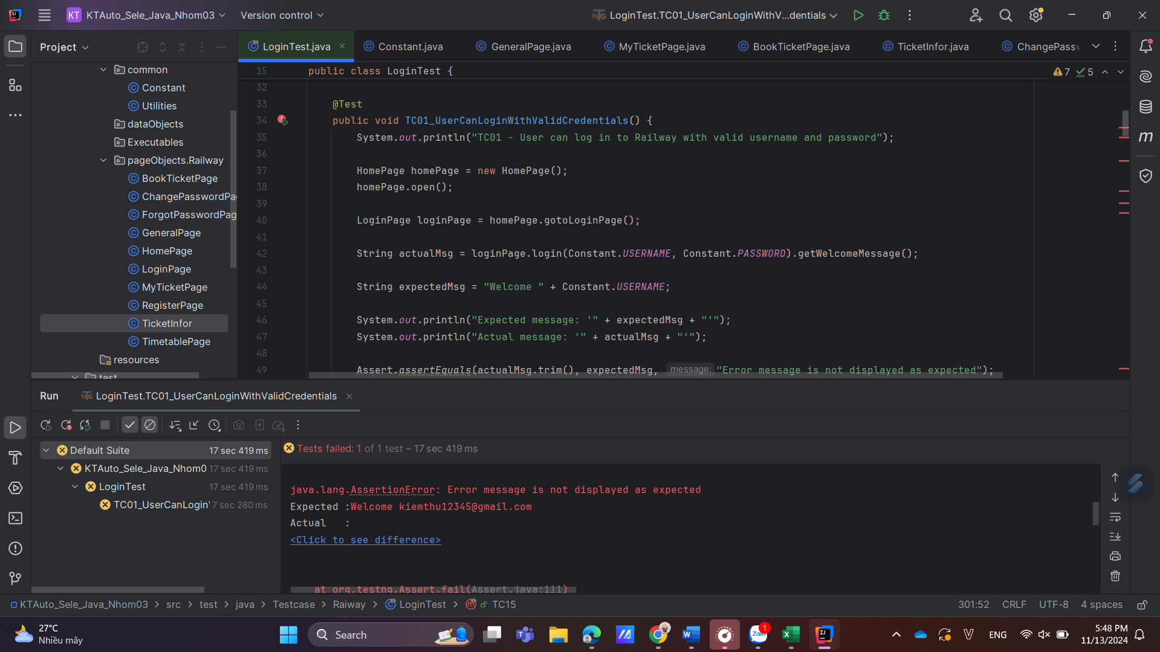

TC01_17H48_13/11/2024_Bug (Expected result different from Actual result_Test manual khoong hiển thị welcome message)

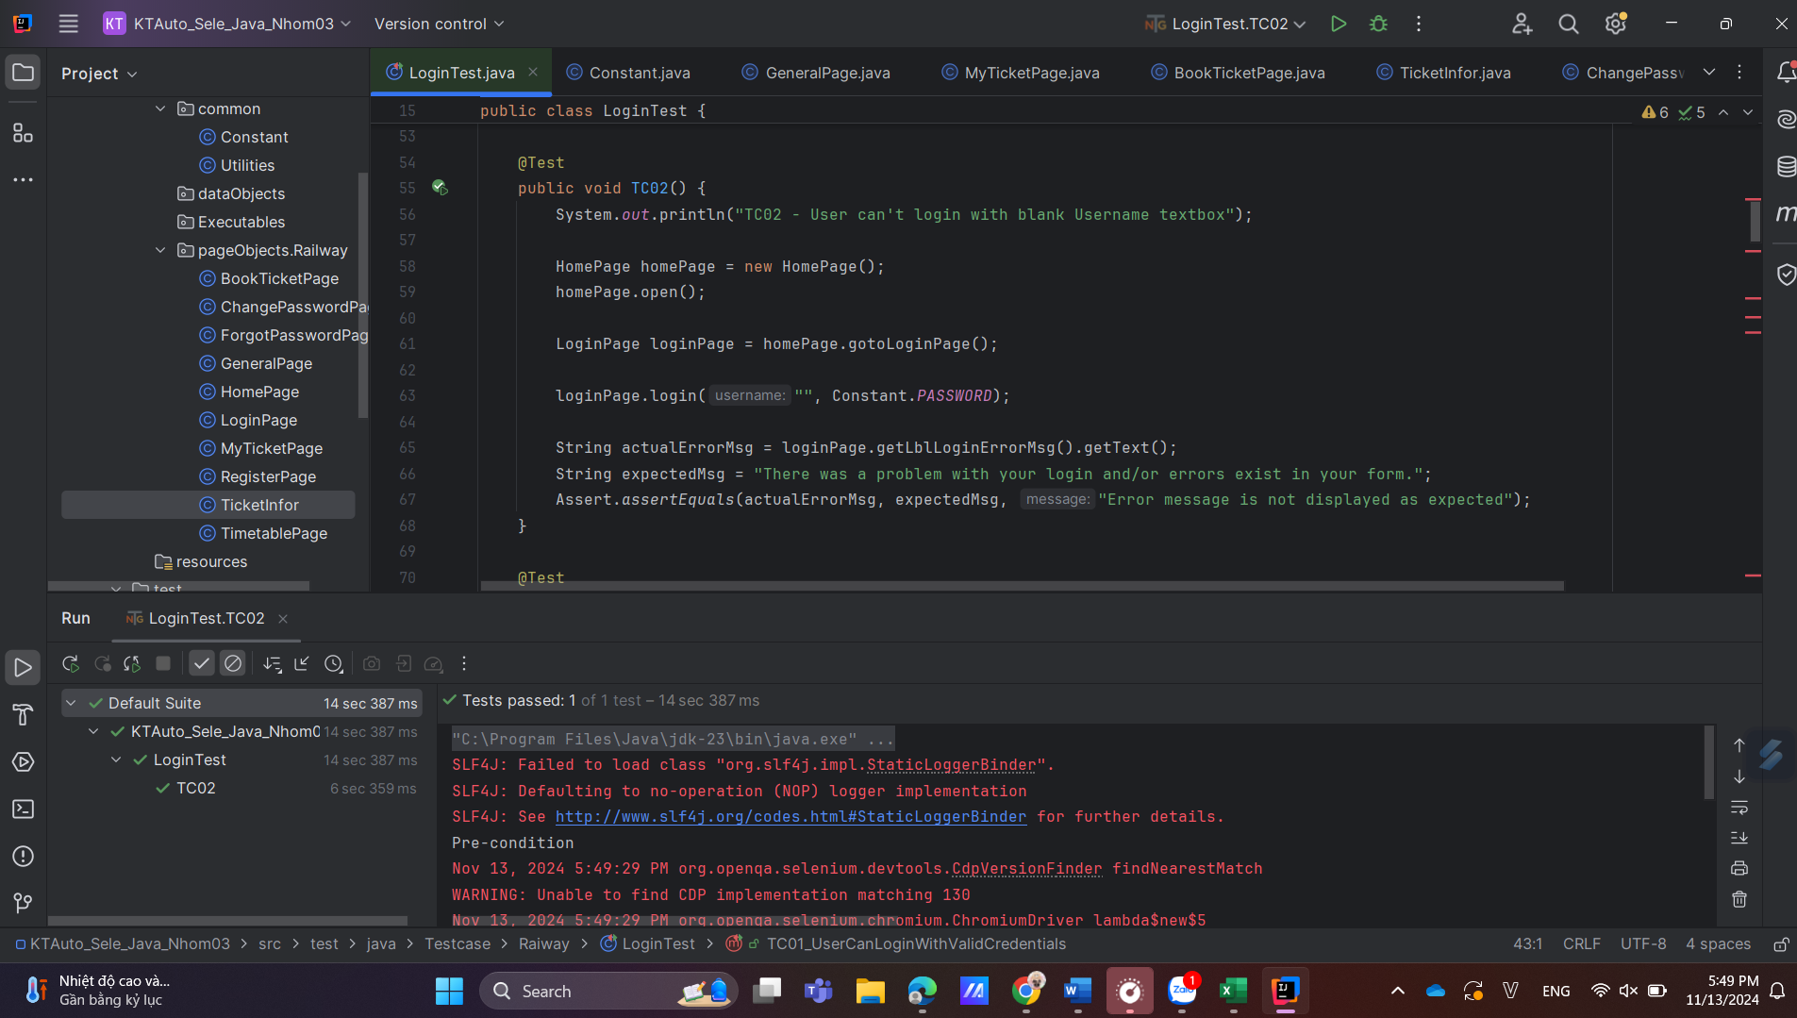

TC02_17H49_13/11/2024_Pass

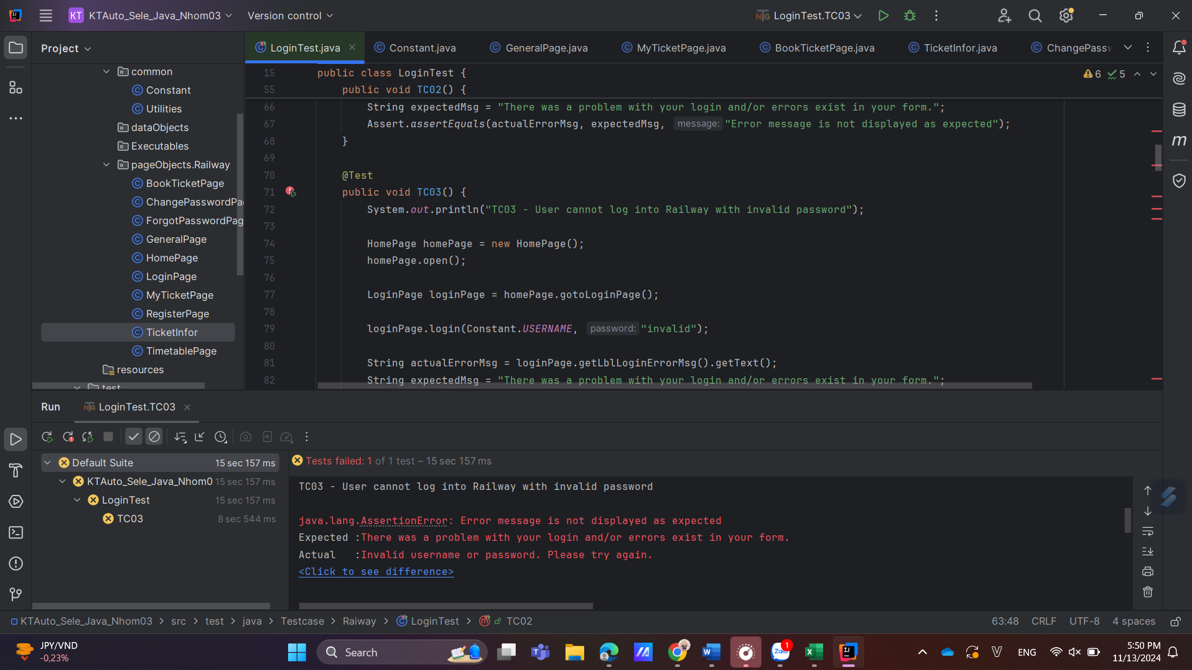

TC01_17H50_13/11/2024_Bug (Expected result different from Actual result)

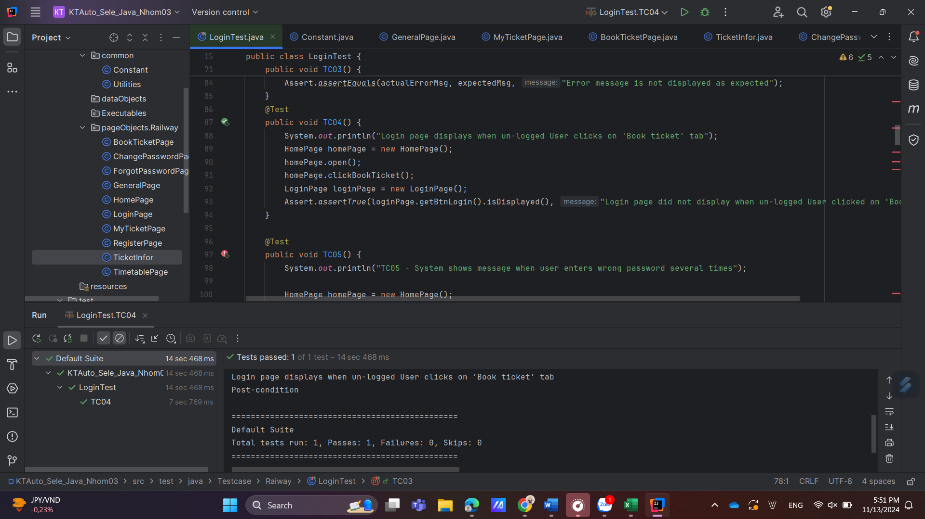

TC04_17H48_13/11/2024_Pass

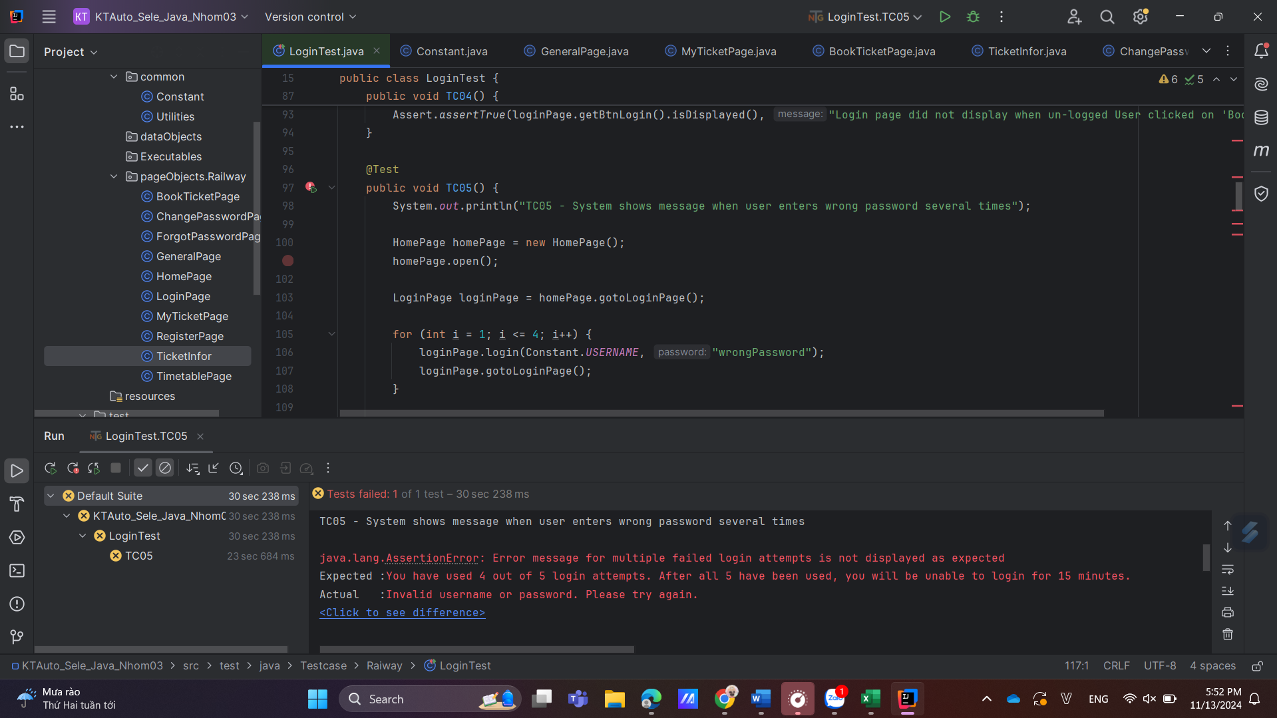

TC05_17H52_13/11/2024_Bug (Expected result different from Actual result)

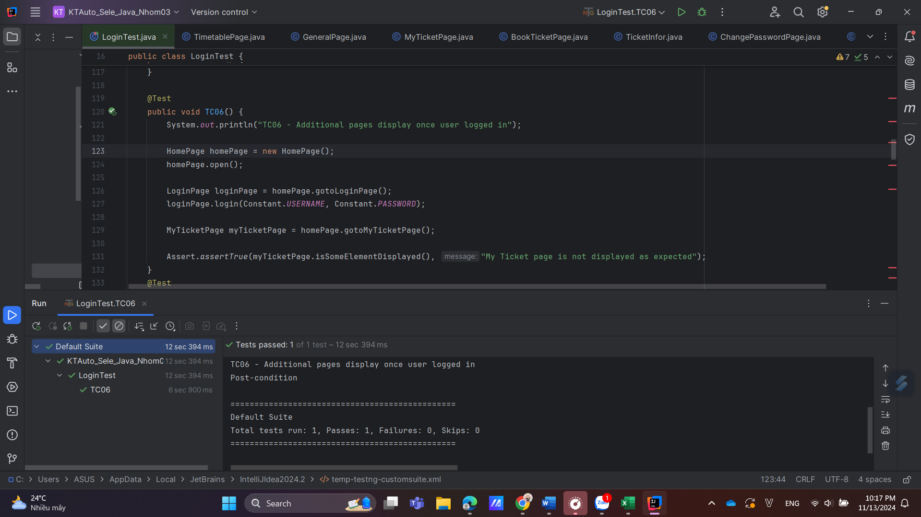

TC06_22H17_13/11/2024_Pass

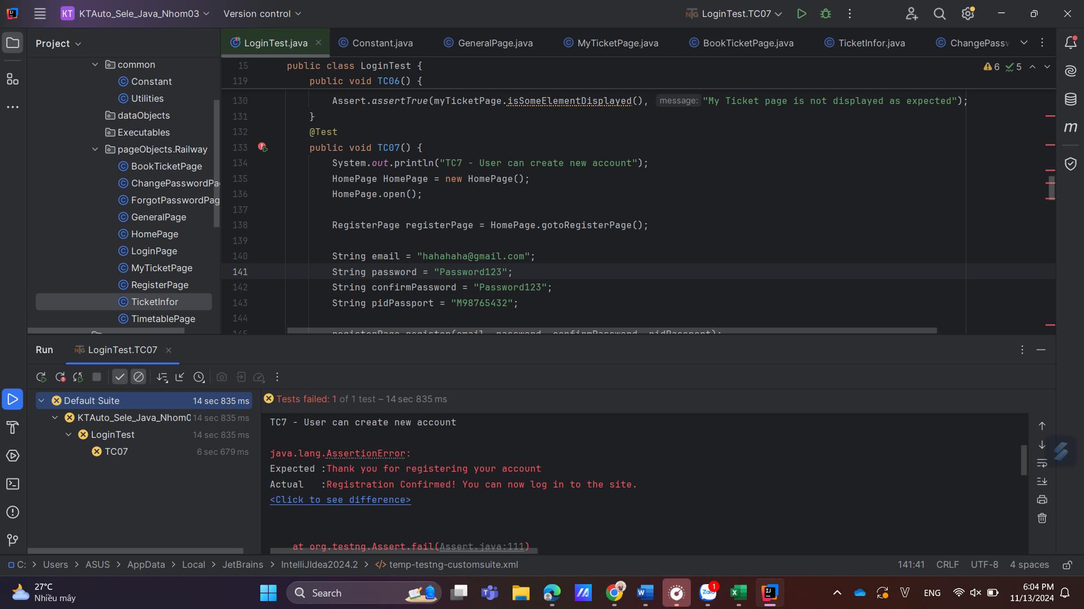

TC07_18H04_13/11/2024_Bug (Expected result different from Actual result)

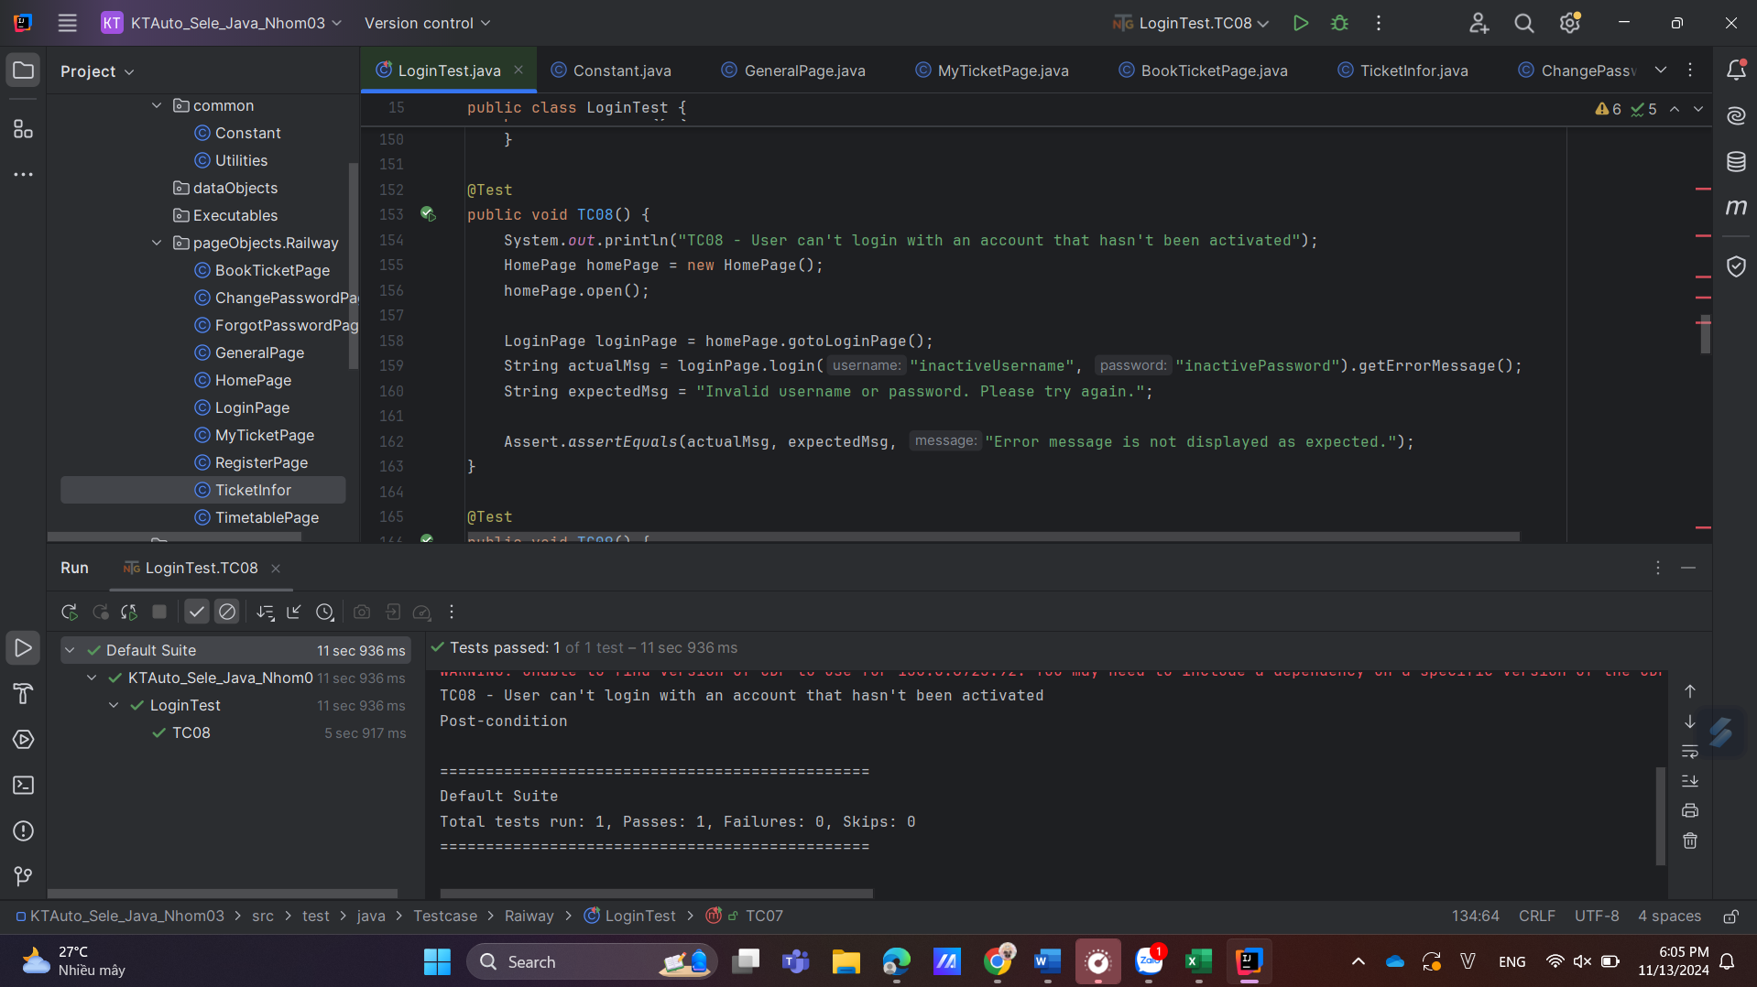

TC08_18H05_13/11/2024_Pass

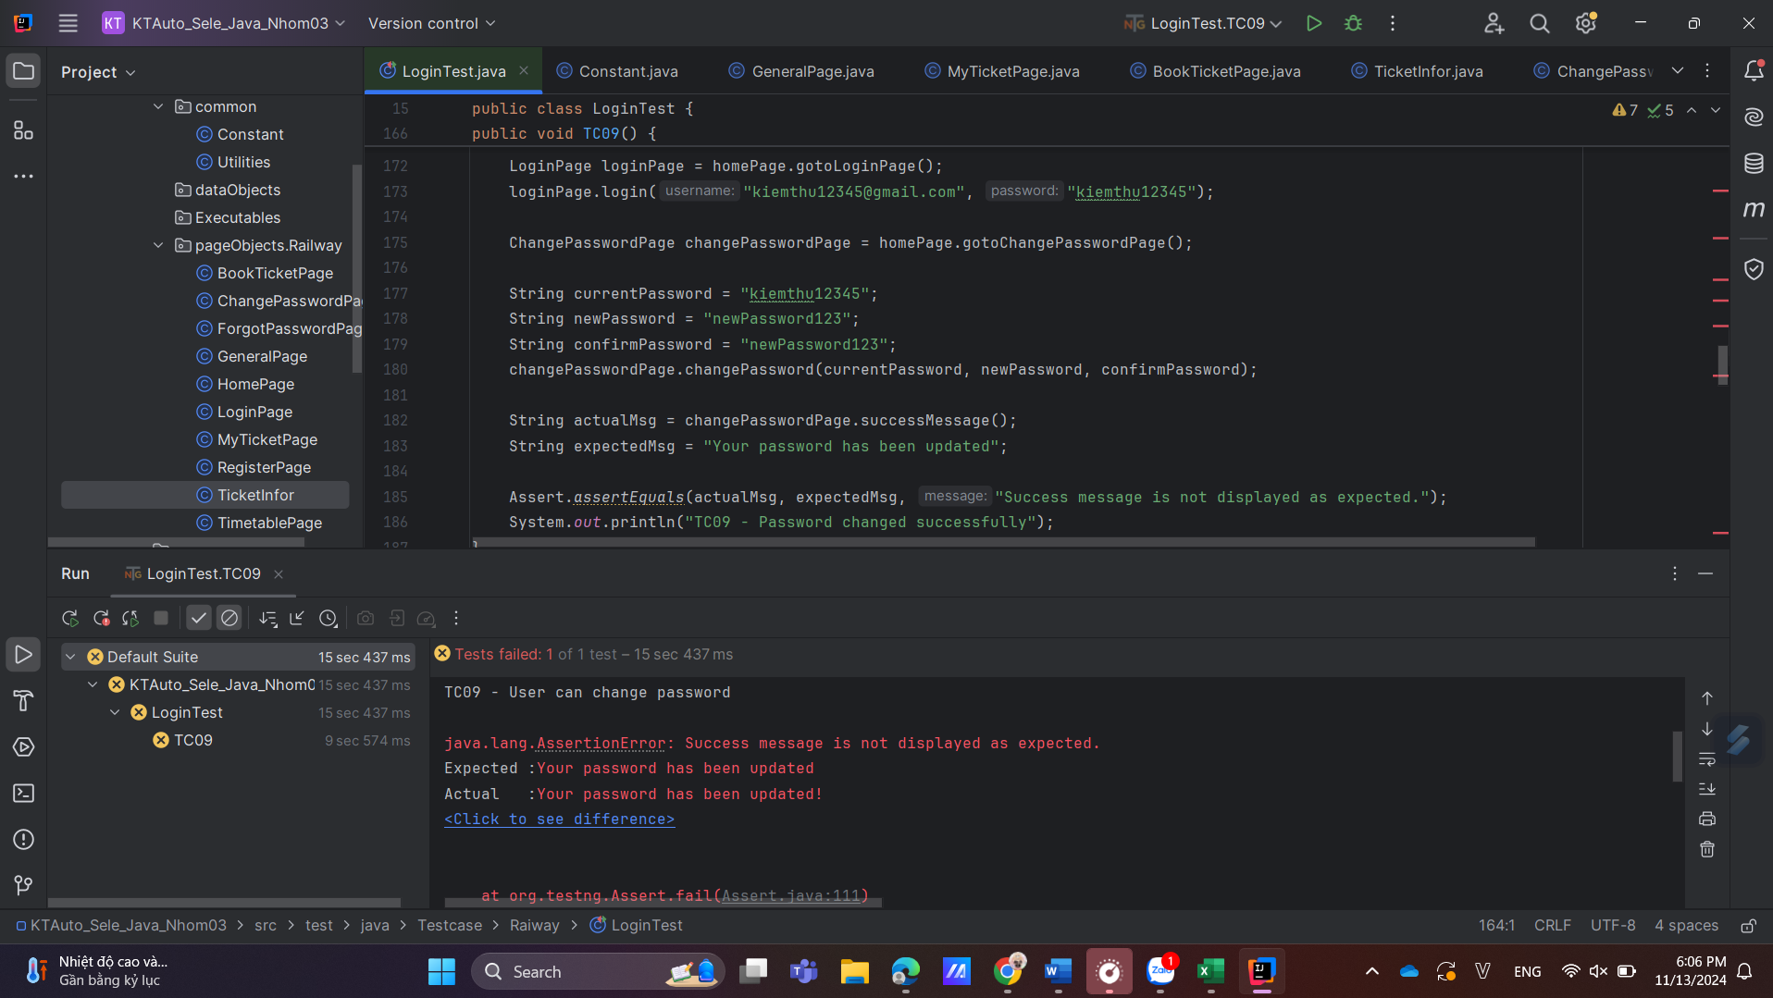

TC09_18H06_13/11/2024_Bug (Expected result different from Actual result_Thiếu dấu !)

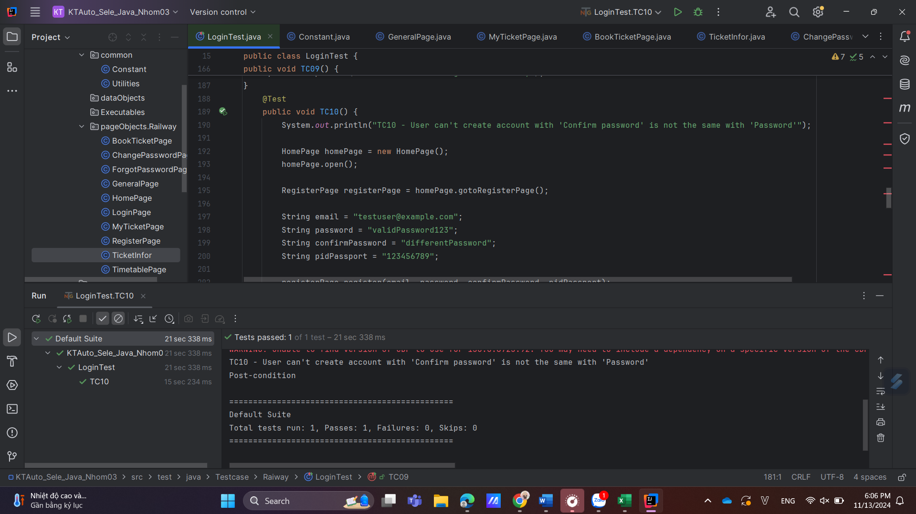

TC10_18H06_13/11/2024_Pass

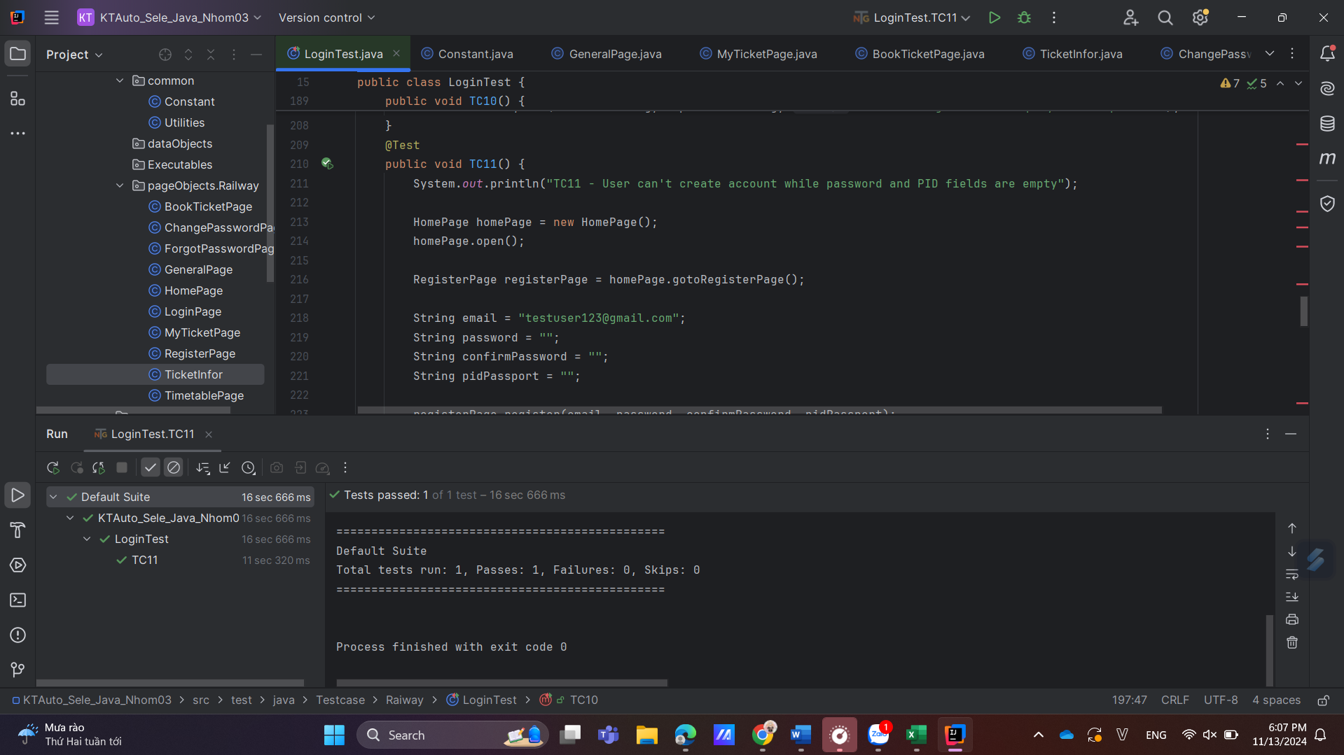

TC11_18H07_13/11/2024_Pass

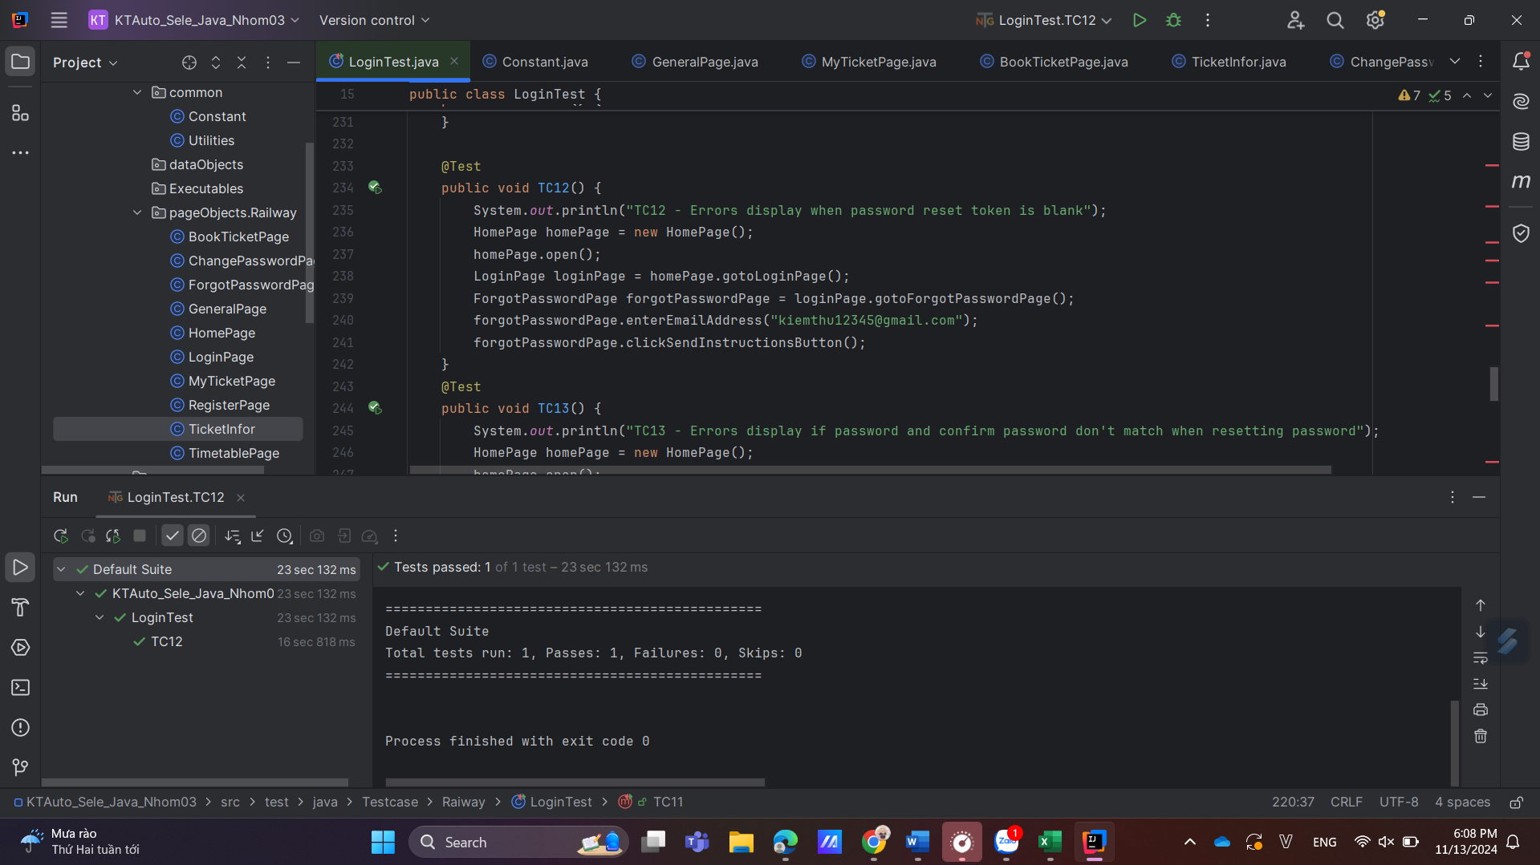

TC12 _18H08_13/11/2024_Pass

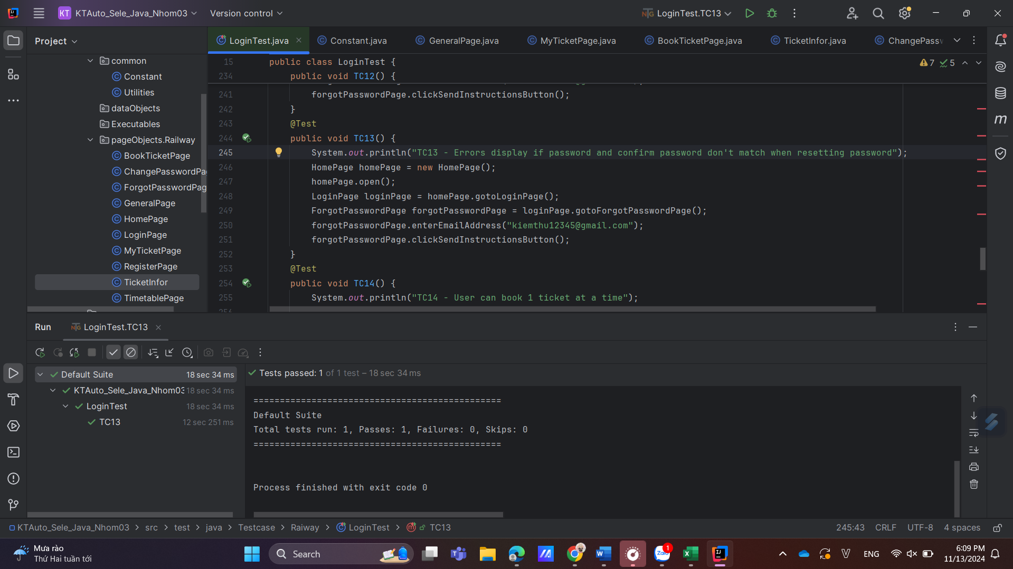

TC13_18H09_13/11/2024_Pass

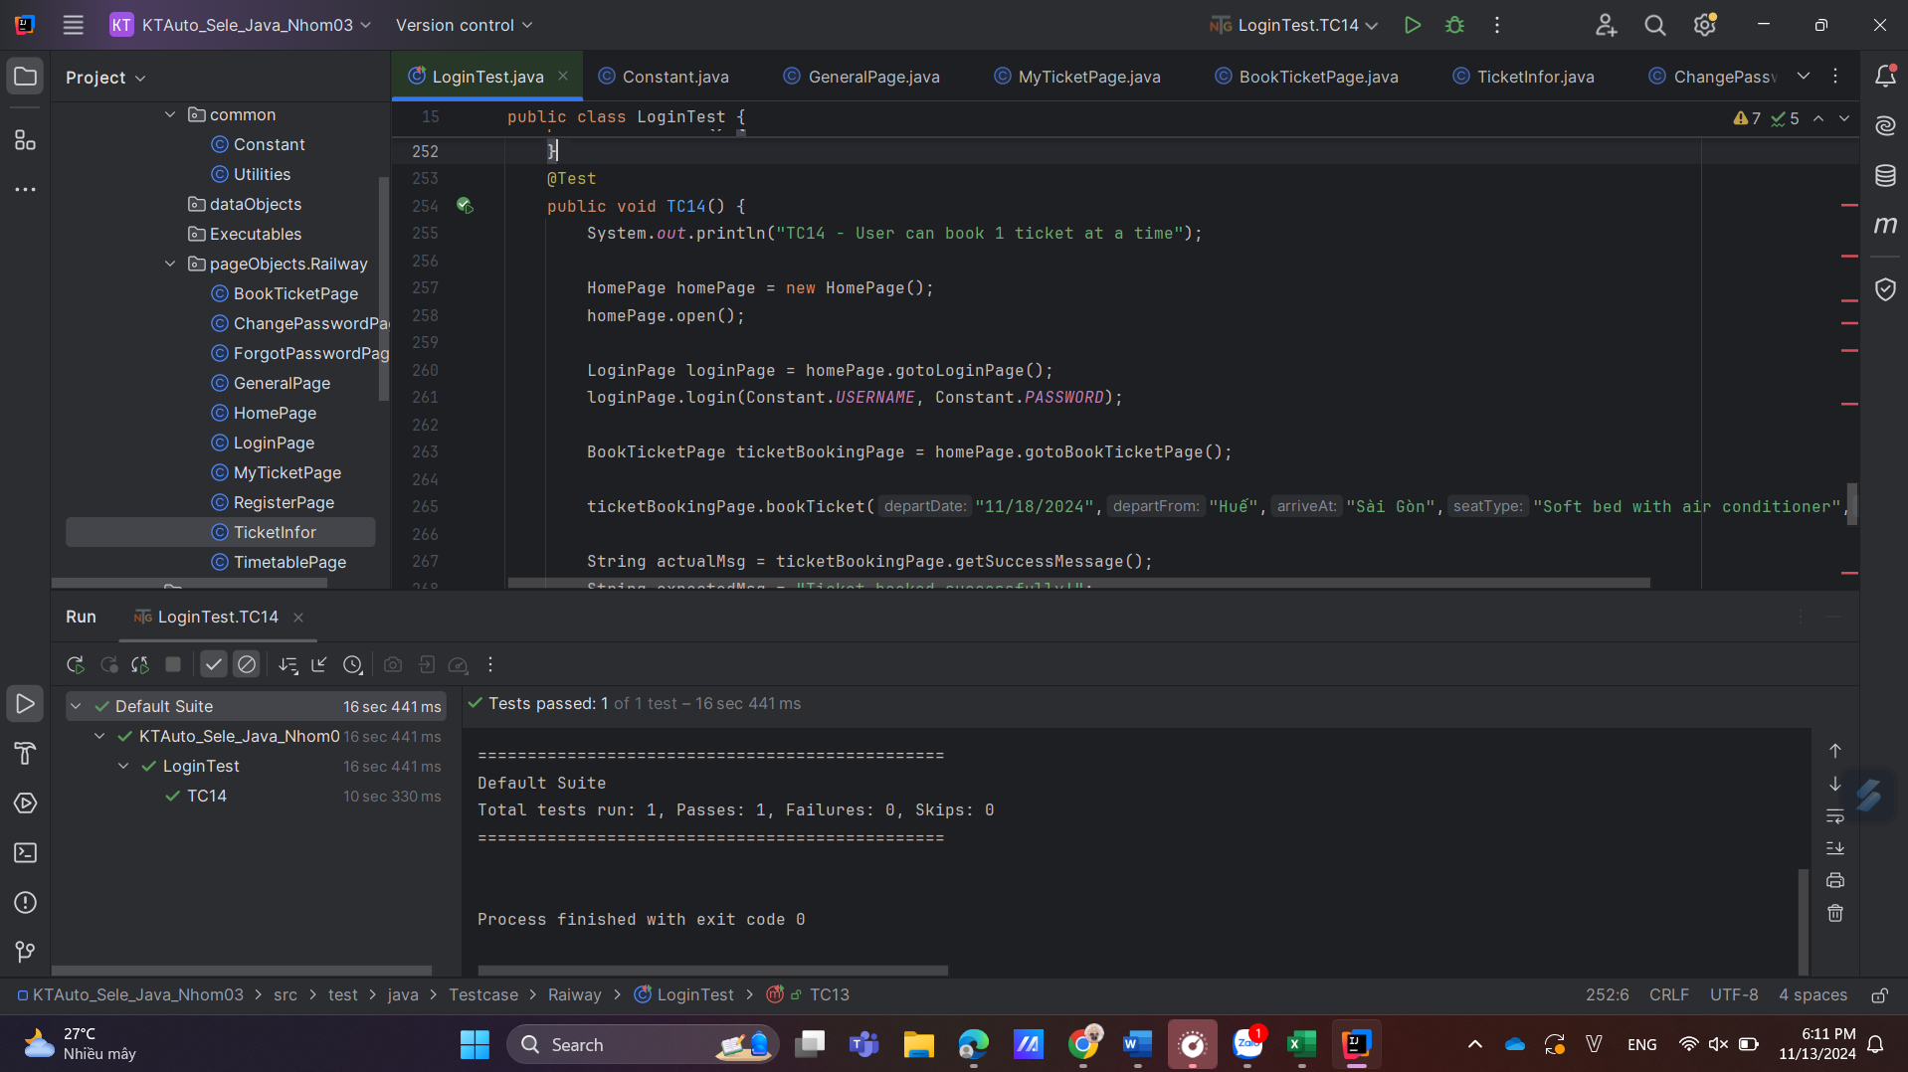

TC14 _18H08_13/11/2024_Pass

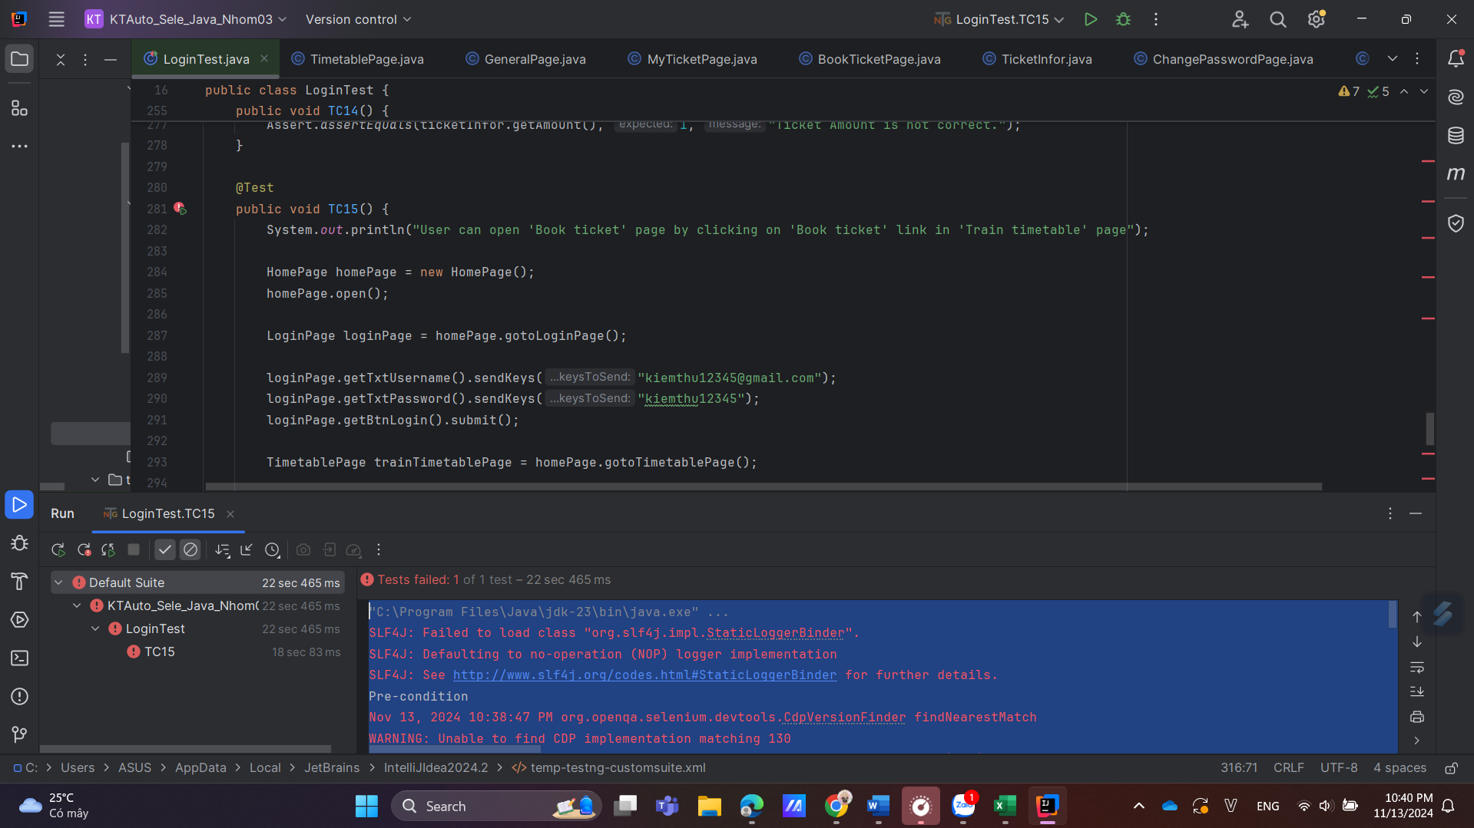

TC15_22H40_13/11/2024_Fail(Do không cuộn được cái scroll bar)

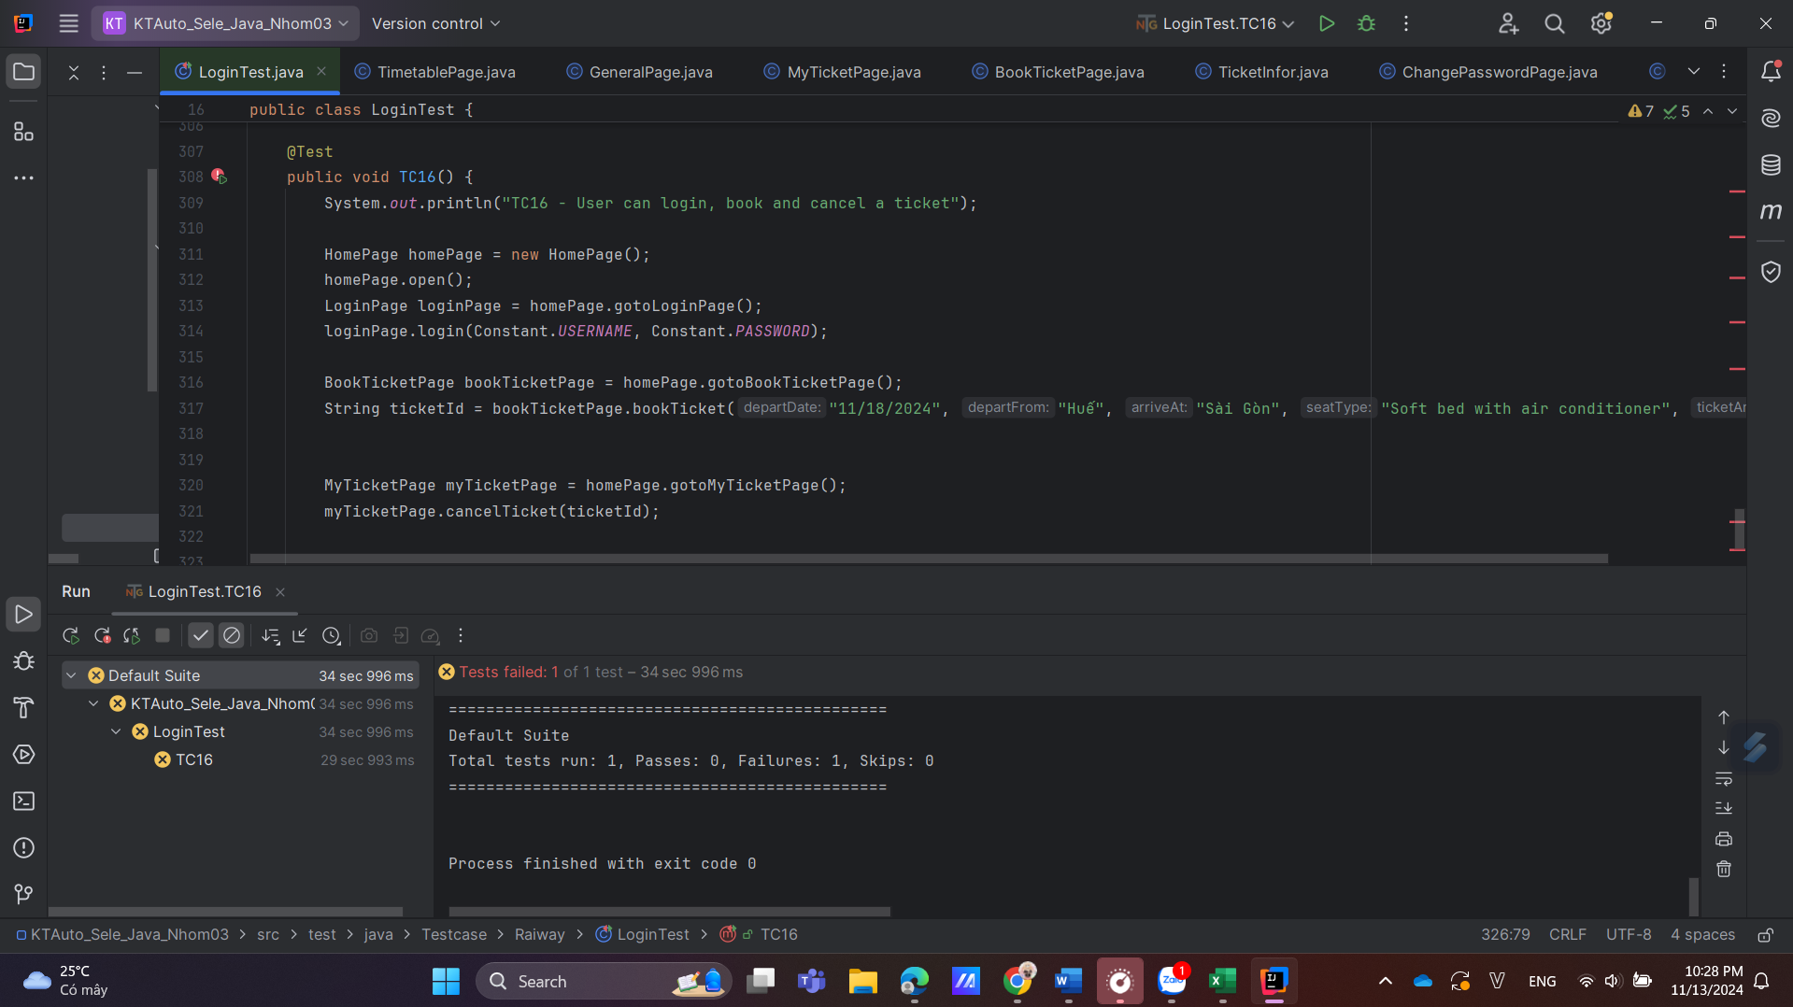

TC16 _22H28_13/11/2024_Bug